
HIGH
PERFORMANCE
PLAN
2013-2015
Ratified ______, 2013
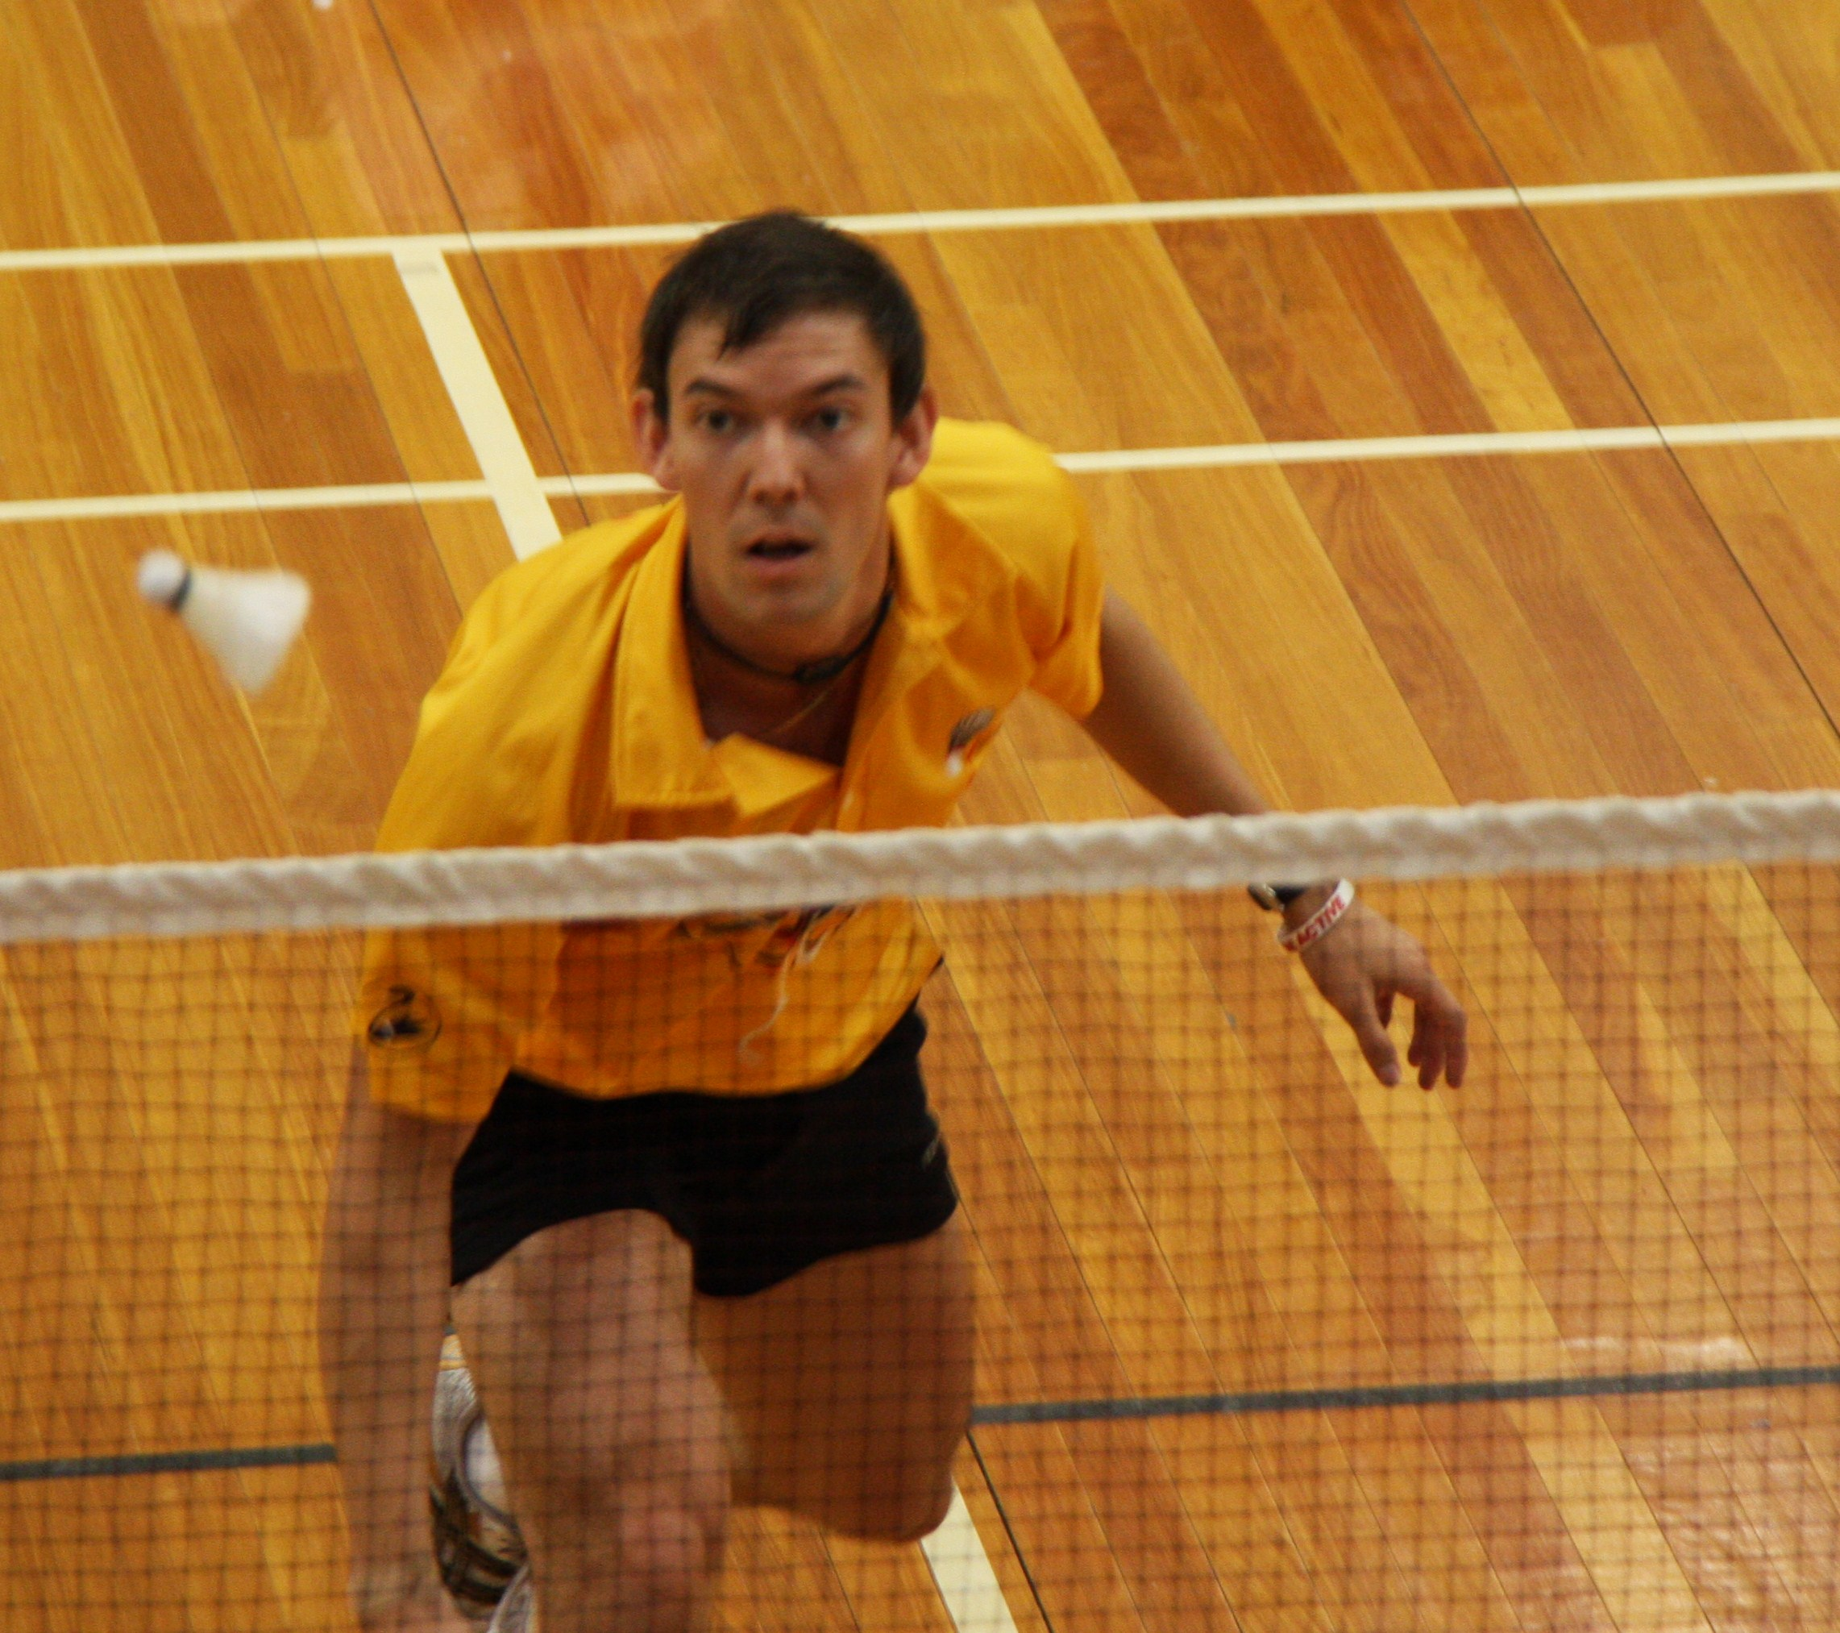
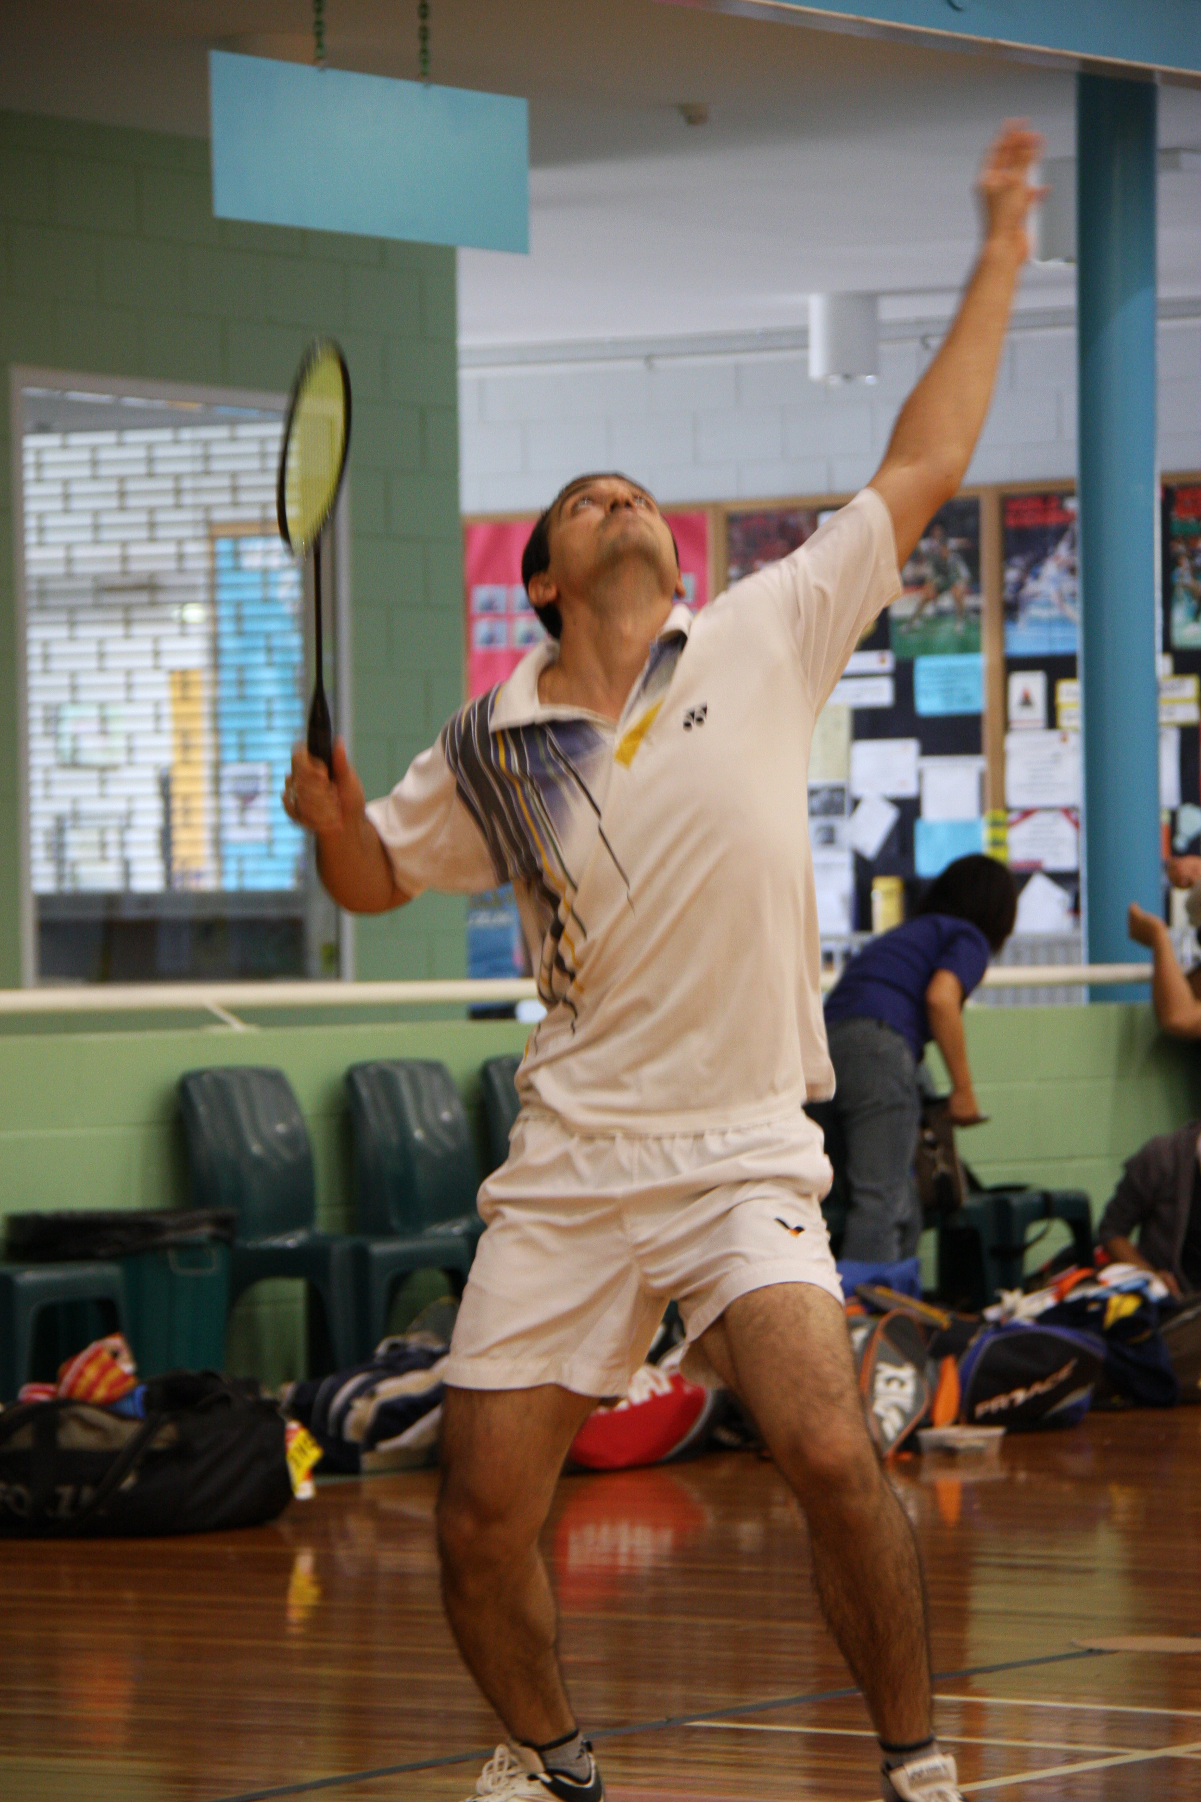
MANAGEMENT TEAM: The High Performance Plan is overseen by the Badminton WA Executive Officer and managed by the High Performance Committee (Chair elected annually). This document is the work of the Badminton WA High Performance Committee.

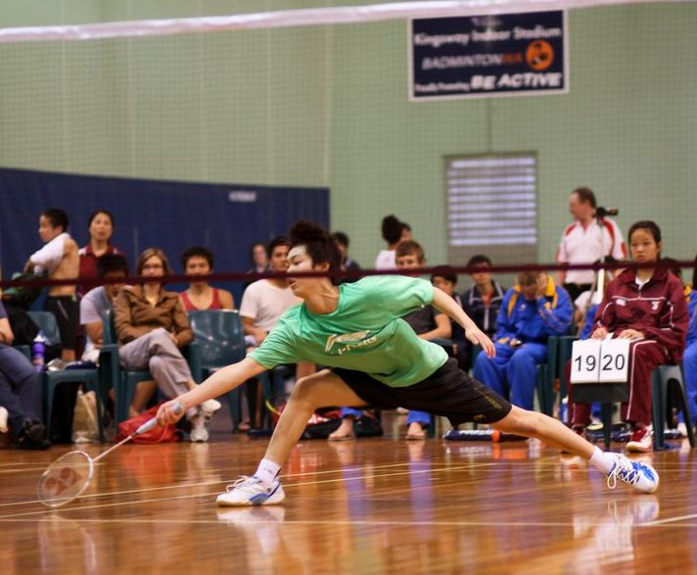
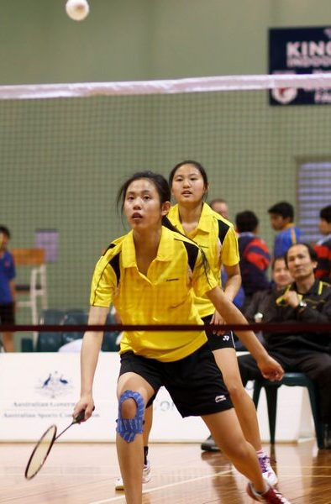
HIGH PERFORMANCE PLAN
PREAMBLE
‘High Performance planning refers to the planning and associated allocation of resources that goes into identifying and developing talent to produce athletes who are capable of achieving success at national level.

High Performance planning is an integral component of a sport’s overarching strategic plan and subsequent operations’. (High Performance Planning Guide, DSR, 2012, p. 6)

- The High Performance Plan needs to be structured for optimal player development leading to sustainable player success.
- The High Performance Plan needs to cover both Junior and Senior players.
- The High Performance Plan should link to the national High Performance programme as that is the pathway for the talented players- indeed interdependence with the national system is the ideal.

The development of this HP Plan requires the following:
- BOM approval that a HP Plan be developed.
- Approve a budget for the implementation of the Plan
- Key personnel appointed to develop the Plan and the delivery of the Plan
- Current situation analysis
- Outcomes clearly defined
- The Plan components to cover:
- Introduction
- Background
- Strategic outcomes
- Key Result Areas
- For each KRA:; Objectives, performance indicators, timeframe and responsibility
- Monitoring and evaluation strategies
- Review and reporting.

This document covers:
- the current situation;
- regional player involvement;
- talent identification
- player pathways;
- events;
- the plan for 2013-15
- budget.
The outcomes to be achieved are to have;
  - A well planned High Performance Plan in place & being implemented;
  - Sustained national success through the provision of an effective and manageable talented athlete pathway;
  - Clear links from Badminton WA HP Plan to the national HP Plan.

CURRENT SITUATION: SUMMARY
The High Performance programme in WA currently consists of:
- Four State teams: Under 15, Under 17, Under 19 and one State Senior Team.
- The State Junior Championships and Senior Championships- annual competitive events.
- Private coaching of talented players by independent coaches.

Badminton Australia has recently (December, 2012) produced a Draft HP Plan that covers both Seniors and Juniors. (see attached). The Badminton WA plan needs to consider and link to this national plan where possible.
Currently the coaching and management of talented players by Badminton WA focuses on the selection and training of the State team players.
There is considerable overlap across these teams with some players representing WA in three State teams in any one year.
In recent years there have been three different Coaches for the four teams. These Coaches do 1-2 training sessions per week leading into the national event- generally this is for an 8-10 week period. The Senior team preparation has been very sporadic- sometimes only 4-5 sessions in total.

STATE TEAMS
Once a player nominates for a State team he/she comes under the jurisdiction of the Association State Team programme and is subject to the appropriate ByLaws- Selection process, Player Agreements, Code of Conduct etc.
Badminton WA appoints the State Team Coach and Manager (who plan the training programme), and financially support the team to the level as shown in the State Team Bylaws.
Players who are not selected in a State team have no follow-up programme to go to and there are times when players represent the State, perform at a national event, return to WA and there are NO follow-up programmes for them, so they disappear until the following year when they once again nominate. Some players simply ‘disappear’ from our sphere of influence and do not ever represent WA again—some do not seem to even continue playing. This does not usually happen with the high performing junior players- who are often self-motivated to continue working with a particular Coach to maintain/improve their skills.
The Senior players have recently shown no indication of wishing to improve or willingness to train in any consistent or focused way. Success has been random—one Team Silver Medal being the highest result. In 2012 no Team medal at the national Championships. Individual results have been achieved by players taking some responsibility for their own training. Having one Senior Internationally successful player in the team has been a bonus and without his input the teams may not have viable, eg, his ability and leadership attracts others into the team.
The Junior teams have been much more committed to the training programmes and generally have been more cohesive and focused. A Team Silver Medal (U15’s, 2012) is the highest result with no Team Medals in U17’s for some years.
The current organisation and management of State teams has been refined and improved in recent times and is working well except for the following areas:
- The information regarding the nomination process is not spread widely enough—eg we are often told—‘I knew nothing about this’.
- The reluctance of senior players to commit to any training programme.
- The ‘net’ to catch players not selected is non-existent;
- After the event the follow-up monitoring and mentoring of those selected is ‘hit and miss’. The best players are generally retained but the No 3-4-5’s often slide away.
STATE CHAMPIONSHIPS
The State Junior Championships follow the Higgs Trophy (a regional Team event in age divisions)
Some of the ‘top’ juniors do not choose to play in this. The event itself does not have enough ‘status’.
The State Senior Championships are quite well supported by the most talented players but it is not seen as being essential to play in this to be selected in the State team.
A decision needs to be made as to whether the above events are an essential requirement to selection in a State team. If this is the case are there any concessions- and if so they must be clearly stated- eg illness, injury (with Doctor’s certificate), national commitment (eg. representing Australia)...?

PRIVATE COACHING
In many sports players have private coaches. This is also the case with badminton.

Currently, the relationship between a player’s private coach and the State Team Coach is not defined or discussed or managed. There is no collaboration between these Coaches.

With Juniors some players only respect their private coach- though most are quite respectful towards the Team Coach when ‘on tour’.

Many Seniors are of the view they do not need any coaching and poor results do not change this opinion.

REGIONAL PLAYER INVOLVEMENT
WA is a large State with the sport being played in the north-west and as far south as Esperance.
In the past a number of players from regional areas have been selected in State teams. Many have made huge sacrifices to make this happen, travelling long distances to attend training—all at their own cost. Currently no Senior players come from any regional area. One recent senior player from Geraldton achieved Australian representation, but she has since retired.
At the Junior level no regional player has been selected in the U15 team, no regional players have been selected in the U17 team (possibly because Geraldton also enters a team in this Australasian event) and there has been some regional representation (from Geraldton) in the U19 team.
There is no plan to tap into regional areas to focus on talented players—we hope that these players will come forward either through the regional association promoting them or through interested parents putting their child forward.
TALENT IDENTIFICATION
‘Talent Identification is the systematic process of identifying and monitoring current athletes with the potential to excel’ (DSR, High Performance Planning Guide, 2012, p. 13)
Badminton WA has no formal Talent Identification process in place for either Seniors or Juniors.

Private Coaches do not always nominate their best players- or indeed encourage their players to nominate for State Teams- either Senior or Junior.

There is no coaching programme that focuses on Talented Senior players. They belong to a social group or university group and nominate for the Senior Team (sometimes after much urging).

Talent is often spotted at events but no-one is charged with the task of identifying these players, or doing any follow-up with them.

There is no general agreement on how ‘talent’ should be defined- it is a personal view—sometimes based on results.

Occasionally talent is discovered almost accidently (word-of-mouth)—eg ‘there is a really good player at Curtin University...’

NON AUSTRALIAN RESIDENTS
In recent years the Senior team has consisted of a number of university students (non Australian Residents but who meet the residency requirements for team selection) with considerable talent but whose commitment to the team is only strong during the event and who are unlikely to have any long-term commitment to the sport in WA. We need to consider this in our HP Plan as to whether time or money should be directed towards these players.
PLAYER PATHWAY
The pathway that players might take from starting in a club, coaching group or social group and how they could progress to representing WA in a State Team and possibly move into the Badminton Australia High Performance Programme is currently not clearly highlighted for public knowledge (eg on the website) and mostly occurs through word of mouth (often between friends or family members) or through a pro-active Coach.
PATHWAY for TALENTED PLAYERS

STATE TEAMS:
U15
U17
U19
SENIORS
TARGETED TALENT
AGE GROUP SQUADS
U15, U17, U19, Seniors- functioning for the whole year
AUSTRALIAN HIGH PERFORMANCE PROGRAMME
Note: Badminton Aust. BOM reserves the right to use any criteria it chooses when selecting teams or squads

PRIVATE GROUPS
INDIVIDUALS

CLUBS and GROUPS.
It is acknowledged that there are a number of private clubs and groups managed by different Coaches functioning throughout the State. Some are junior groups, some are senior groups and some are a mix of both.

Some groups are run by a qualified Coach, other are just a group of people who come together to play the sport.
Players from these private groups nominate for State Teams.
Sometimes Coaches encourage their players to nominate to State Teams.
Some Coaches seem reluctant to encourage their players to nominate for State Teams.

Selection trials are held and State Teams chosen.
This pathway now includes the establishment of Age Group Squads – players would not need to necessarily be in these squads to gain selection in State teams.

State team players have the possibility of gaining a Carnival ranking which may bring them to the attention of the National selectors.
NATIONAL SQUADS—see BA HP Plan
SENIORS: Rankings at Commonwealth Games, Olympic Games, World Championships, Oceania Championships and World ranking gives automatic entry into the Elite Group /Development Group. Note- a player must be selected into an Australian team to attend the Commonwealth Games & Olympic Games. The World Championships have qualifying criteria. The Oceania Championships are Open. A World Ranking of 1-40 gives automatic entry into the Elite Group and 41-100 to the Development Group.
JUNIORS
Automatic selection in the Elite Group requires Ranking of No 1 at the Australian Junior International and the Oceania Junior Championships. National rankings to be used for selection purpose are not yet determined. Ranking of 1-8 in Doubles and 1-16 in Singles at World Juniors gives automatic selection.

At this time there is no indication of how anyone else might be selected into one of the Australian Squads.

6
HIGH PERFORMANCE PLAN for 2013-15
INTRODUCTION
There should be a clear link between the national HP Plan as planned and managed by Badminton Australia and the Badminton WA HP Plan. Athletes should move from the State level to the National level in a seamless transition. It is therefore necessary that the Badminton WA Plan needs to take cognizance of the BA Plan and where possible make clear links.
The VISION of the Badminton Australia HP Plan is:
‘Develop athletes that can win medals at the Commonwealth Games, Olympic Games
and World Championships.’
The Badminton WA VISION is:
To maximise the success of Western Australian athletes, coaches and officials at State, National and International levels.

The MISSION of the Badminton Australia HP Plan is:
‘For Badminton Australia to provide the necessary leadership, products and services to support and strengthen High Performance activities- national, state and local.
Creating a high performance system, where all talented junior and senior players, coaches, state associations and club/academies are aware of and contributing to the pathway to International World Class Badminton.’
The WA MISSION is:
‘Develop athletes who can win medals and gain rankings at National events, such as:
- The Australian U15 Badminton Championships
- The Australasian U17 Badminton Championships
- The Australian U19 Badminton Championships
- The Australian National Senior Championships
- The Australian Junior International

This Plan and budget focuses on the High Performance development of targeted talented ATHLETES. Coaching development and Court Official Development, plus Technical Officer and Manager development - both leading to High Performance success –are shown in KRA Support Personnel Development but these areas (and their accompanying budgets) are further developed in other documents
NOTE: Any HP Plan is, of necessity, constricted by the budget and the resources required to carry out the Plan. The resources include Coaches, availability of courts, provision of shuttles.
BACKGROUND
The previous section has considered the current situation in WA.
THIS ONLY relates to ATHLETE DEVELOPMENT—not Support Personnel
A summary as in a SWOT Analysis shows:
STRENGTHS  WA has a proud history of producing Australian players.  The BOM is keen to produce a HP Plan that is practical and able to be implemented.  WA has a small group of talented players capable of representing Australia.  WA has several well qualified and experienced Coaches capable of training talented players. | WEAKNESSES  Little money to initiate and develop a significant HP Plan  Difficult to find available courts at needed times  Court Hire is becoming very costly  Coaches are not always interested in training State Teams or squads  Some Coaches have high Coaching fees  The overall base of talented players is small  There is no Talent Identification process in place.
OPPORTUNITIES  We have one Coach with recent international experience and high local profile who can successfully promote any programme.  We have a small group of quite talented players keen to progress further.  We have a large Asian/ethnic population that we do not tap into to a great extent. | THREATS  Competing sports  Players choosing between sport and study  Big player loss after 18 years  Few girls in ANY Badminton WA programme- what this means for the future?
GAP ANALYSIS SUMMARY
SITUATIONAL ANALYSIS:
The current HP Programme is the preparation and management of four State Teams.

OPPORTUNITY ANALYSIS:
We have the will and skills to plan, prepare and implement a sound HP Programme

GAP ANALYSIS:
We have a limited HP Programme in place that needs to be refined and developed.

RECOMMENDATIONS
A three year HP Plan be developed with matching budget and phase one commenced in 2013
STRATEGIC OUTCOMES

KEY RESULT AREA (KRA): PLANNING, MANAGEMENT and POLICY

OBJECTIVE: To develop a policy structure that will guide the HP Plan

Key strategies | Timeframe | Performance Measure | Evaluation | Comment
Put in place a three-year HP Plan that can be implemented | March/April 2013 | HP Plan is ratified by the BOM at the 2013 April Board meeting | BOM Minutes show Plan is ratified | HP Plan to be reviewed annually
Select the Drivers of the Plan | April 2013 | 2013 plan is started by April 2013 | Drivers appointed | Drivers to be HP Manager and U15 Targeted Talent Coach, with support from HP Committee
Set the budget | March/April 2013 | Budget receives approval of BOM at April meeting | Budget for 2013 is balanced at 31st Dec 2013 | Prepare a budget for 2014 for the annual Badminton WA budget
Prepare player documentation | April, 2013 | Codes of Conduct reviewed  Player contracts written and signed | Documents on file in the Badminton WA office
Prepare Management Team  (Coach & HP Manager) documentation | April 2013 | Management contracts for Coach and HP Manager written and signed | Documents on file in the Badminton WA office
Identification of links with  BA HP Plan | April 2013  Meet in 2013 | Links shown in a summary sheet | Management team meet with BA HP Manager

.

KEY RESULT AREA (KRA): ATHLETE DEVELOPMENT
OBJECTIVE: To provide a structure for talented athletes that will move them through the Player pathway from identified talent to Australian representation.

Key strategies | Timeframe | Performance Indicators | Evaluation | Comment
Provide travel scholarships for Juniors and Seniors in the BA Elite squad. | 2013-14-15 | Three (3) travel scholarship provided | One Junior and One Senior are selected in the BA Elite Squad | The number of scholarships possible is dependent on the BA Selection process.
Provide travel scholarships for Juniors and Seniors in the BA Development Squad | 2013-14-15 | Three (3) travel scholarship provided | Two Juniors and One Senior are selected in the BA Development Squad | The number of scholarships possible is dependent on the BA Selection process.
Establish the U15 Targeted Talent Squad | 2013 | A group of ten (10) players are selected for the squad. | Squad functions for 30-40 weeks.
Establish the U17 Targeted Talent Squad | 2014 | A group of ten (10) players are selected for the squad. | Squad functions for 30-40 weeks. | Funding may preclude this squad from being established till 2014
Establish the U19 Targeted Talent Squad | 2015 | A group of ten (10) players are selected for the squad. | Squad functions for 30-40 weeks. | Funding may preclude this squad from being established till 2015
Establish the Senior Targeted Talent Squad | 2015 | A group of ten (10) players are selected for the squad. | Squad functions for 30-40 weeks. | Funding may preclude this squad from being established till 2015
Ensure the State Championships have sufficient prize money to attract high standard players | 2013-14-15 | All players in the U15 squad compete in this event.  Minimum prize money is $2000 | All U15 squad compete.  Prize money of $2000 is provided | An effort should be made to enlarge this prize money and promote the event interstate.
State Teams to continue using the current processes | 2013-14-15 | All four State Teams finish in third place or higher at the National carnivals.  Players receive Carnival rankings | 4 players with ranking at each Carnival

KEY RESULT AREA (KRA): COMPETITION
OBJECTIVE: To provide a competition programme for State Team players and Targeted Talent players that will help them move towards national selection

Key strategies | Timeframe | Performance Indicators | Evaluation | Comment
To provide opportunities for talented players to have appropriate competition. | 2013-14-15 | Five Metropolitan State Open tournaments are held each year.  Two regional Open events are held each year | State Team players and Targeted Talent Players compete in 5 State tournaments per year
To provide opportunities for talented players to be selected in State teams to compete at national events | 2013-14-15 | Select, train and manage four (4) State teams who compete at the national carnivals | WA represented at all national carnivals
Support International events by providing Travel Scholarships | 2013-14-15 | Five players compete in international events each year. | Five players compete and reach the second round of their events
Apply to host an international event | 2015 | Badminton WA is successful in gaining hosting rights for an international event in 2016 | An international event is held in 2016. | This would require assistance from BA, State Tourism OR DSR
Establish an exchange programme with an Asian neighbour. | 2014-15 | Organise an overseas group to come to WA for a ‘friendly’ competition. | An invitational event is held. | May require assistance from BA, State Tourism OR DSR

KEY RESULT AREA (KRA): SUPPORT PERSONNEL
OBJECTIVE: To have sufficient Coaches and Officials to support and develop the HP Plan.

Key strategies | Timeframe | Performance Indicators | Evaluation | Comment
Coaching courses are run. | 2013, 14, 15 | A minimum of one coaching course is held annually | Four people undertake the course
Coaches are advised of their requirements to update their qualifications | 2013, 14, 15 | A Coaching Committee is established | All Coaches obtain re-accreditation on application
Referee courses are organised | 2013, 14, 15 | One Referee course is run each year | One new Referee qualified annually
Umpiring courses are organised | 2013, 14, 15 | Each State Team is given a session on Umpiring.  A travelling umpire is provided for each State Team | Two new umpires are qualified annually
A Line Judge course to be held bi-annually | 2013, 15 | Line Judges receive WA Certification | Four Line Judges receive WA certification annually
Technical courses are held | 2013, 14, 15 | A course in using Tournament software is held | Three people complete the course.
State Team Managers are briefed and de-briefed after tours | 2013, 14, 15 | All Managers briefing and de-briefing sessions are held | HP Committee assess de-briefs and update ByLaws and reporting processes

MONITORING AND REVIEW

- The Badminton WA HP Plan is ratified by the Board of Management .

- The Badminton WA Executive Officer oversees the financial aspects of the implementation of the Plan i.e. prepares invoices, receipts, banks money etc...

- The Executive Officer records all financial transactions and manages the budget in consultation with the Committee Chair.

- The Badminton WA High Performance Committee manages the programme
---- the Committee members should each have a specific role- clearly recorded- with the Chair of the Committee allocating and monitoring that tasks are done.

- The HP Committee meet regularly (eg 3-4 times a year) to review the Plan and also to assess the implementation of the programme.

- The Chair of the HP Committee reports to BOM meetings – at least 4 times a year.

- The Chair of the HP Committee prepares a report on the programme for the Badminton WA Annual Report

- The HP Committee present a budget to the BOM for consideration for the following year.

- The HP Plan is placed on the Badminton WA website.

- The HP Plan is reviewed annually by the HP Committee – in particular assessing KPI’s and timeframes. Recommendations to be brought to the Badminton WA BOM.

BUDGET SUMMARY- only Athlete Development - details follow

Activity | Cost | Income | IMPLEMENT
Junior HP Travel Scholarships | $2000 | Shown as Player Development in main budget | 2013
Senior HP Travel Scholarships | $2000 | Shown as Player Development in main budget | 2013
Establish U15 Targeted Talent Squad | $2000 | Shown as Player Development in main budget for 2013 | 2013
Establish U17 Targeted Talent Squad | $2000 |  | 2014
Establish U19 Targeted Talent Squad | $2000 |  | 2014
Establish Senior Targeted Talent Squad | $2000 |  | 2015
Competition | $2000 (2013)  $3000 (2014)  $4000 (2015) | Provide sufficient prize money to attract players to make this a worthwhile event for the HP Players | 2013-4-5
Management fee | $500 |  | 2013
TOTAL for 2013 | $8500

NB: Budget for Player Development for2013 is $6000. State Championship prize money is allocated from Event budget

BUDGET DETAILS: 2013
Junior Travel Scholarships: $2000
Any players selected in the BA Elite Squad to receive $750 each to assist with travel to a national event. Paid on receipt.

Any players selected in the BA HP Development Squad to receive $500 each to assist with travel to a national event. Paid on receipt.

Senior Travel Scholarships: $2000
Any players selected in the BA Elite Squad receive $750 each to assist with travel to a national event.
Paid on receipt.

Any players selected in the BA HP Development Squad receive $500 each to assist with travel to a national event. Paid on receipt.

Under15 Squad. $2000
Players will be invited into the squad- to a maximum of 10 players with an equal split of boys and girls.
Players will be required to pay $10 for the weekly session. To be paid in 4 tranches to cover 40 weeks.
Coach will be paid $100 for the session.
Badminton WA will pay the court hire to the value of $1600, ie. 2 courts for 1.5 hours for 40 weeks
Badminton WA will provide 5 tubes of shuttles- anticipate that used shuttles will be required.
Badminton WA will provide $400 for Assistant/sparring costs.

Competition $2000
Badminton WA will provide a minimum of $2000 in prize money for the 2013 State Championships.
This will come from the main account.

Management Fee $500
A HP Manager will be appointed to oversee the Plan:
Tasks:
To keep account of expenditure;
Collect fees from players (to be paid in tranches, not weekly);
To be the liaison person between the players, Coach, EO and BOM;
Attendance at a minimum of 4 squad sessions will be a requirement;
Ensure players are informed of events, both State and National;
Overseeing player entries into events
Such fee to be paid in two tranches, one after 20 weeks and the second after forty weeks.

These costs (apart from the $2000 State Championships prize money) will come from the Player Talent Development budget ($6000 for 2013)

BADMINTON AUSTRALIA

Badminton Australia has recently produced a High Performance Plan. This is available in the Badminton WA office.
At this point it does not appear to be ratified by the BA BOM and indications are it is solely the work of the National Coach- though this is not shown in any part of the document.

The key performance Measures for Target Events cover 2013-14-15-16-17-18—so one assumes the rest of the document also refers to these years.

The Badminton Australia High Performance Programme covers both Senior and Junior players.

Currently no Senior players from WA are in this programme. To gain selection they must have met or have the potential to meet the ranking guidelines which relate to Commonwealth Games, Olympic Games, World Championships, Oceania Championships and World Rankings. They must commit to 10 International tournaments per year. They need to be selected into the programme before they receive any financial support.

NB A independent player can gain World rankings by competing in International events BUT an independent player cannot compete at the Commonwealth Games, or Olympic Games without being a representative of their country (eg selected by Australia).

Currently three WA Junior players have been selected in the Development Group- Phing Teo, Xiang Lin, Tyzton Tan.
The Badminton WA HP Plan provides travel scholarships to assist players (Seniors and Juniors) to travel to events. This may help the Juniors to meet the guidelines for continuation in the Development Group.
Ensuring that WA players in any BA HP Group have the appropriate training is not mentioned in the BA Plan-apart from the point that players must commit to a well-structured program of daily training with their own coach- and no contact has been made with Badminton WA to tell us who the Coaches of the three players in the Junior Development Group are- and any role we should play in their development. The reporting procedure between local Coach and the National Coach is not mentioned. The BA HP Plan states: ‘BA will work closer with athletes, parents and coaches to develop a singular approach to each players development’. This requires clarification on how this will be done—eg what is the process?
The BA HP Plan also states ‘Work with states on developing centralised training for top players outside Melbourne’. Again there is no indication on how or when this will occur.
There is no information in the BA HP Plan to show how the Members can link their elite players into this national plan. No direct communication has come from the National Coach to the State Body regarding the role we should play in supporting this national HP Plan.
It may be valuable for the Badminton WA Hp Committee to ask for clarification on a number of aspects of this national plan.

BADMINTON AUSTRALIA HIGH PERFORMANCE SENIORS PROGRAMME

BA SENIORS ELITE GROUP
-daily training
-10 international tournaments
-Min $10,000 each for international comp.

Selection in Australian Teams is not restricted to those players within the Badminton Australia National Squads and a separate selection policy will be created for each Australian Team.
Australian Senior Teams are fully funded.
Currently WA only has three players who have the possibility of being selected in either of these national senior squads: Nick Kidd, Joyce Leong, Eddie Hung (based on past performances), though Joyce may not meet residential requirements. None of these players has been listed in the Elite or Development Group.
The Badminton WA HP Committee needs to confirm whether these three players intend to commit to a training and competition programme that would meet the requirements of the BA HP Programme
To date Badminton WA has not been contacted by BA to discuss the plans or programmes of any Senior players.
From the above criteria for selection into BA HP Programme it can be seen that National ranking or National Carnival ranking is not part of the selection process.

Development Group have lower tournament results or rankings
Commonwealth Games: 9-16
Olympic Games: 17-32
World Championships: 16-32
World Ranking: Top 100

Elite Group have high tournament results or rankings.

Commonwealth Games: 1-8
Olympic Games: 1-16
World Championships: 1-16
World Ranking: Top 40
BA SENIORS DEVELOPMENT GROUP
-potential to move to Elite Group
-Daily training
-10 international tournaments
-Min $2000 for International comp.
BADMINTON AUSTRALIA HIGH PERFRMANCE JUNIORS PROGRAMME

BA JUNIOR ELITE GROUP
-daily training
-5 international tournaments annually
-5 domestic tournaments annually
-1 return airfare to participate in national training
-Financial support for international competition not determined.

BA JUNIOR DEVELOPMENT GROUP
-potential to move to Elite Group
-Daily training
- 3 international tournaments annually
-5 domestic tournaments annually
-Can apply for funding from the Junior Development Funding pool (TBC).
Elite Group have high tournament results or rankings.

Aust Junior International: 1
Aust Championships (U15, U17 , U19) TBC
World Junior Championships: 1-16
Oceania Junior Championships: 1
World Junior Ranking: Top 40
Development Group

No information provided

Selection in Australian Junior Teams is not restricted to those players within the Badminton Australia National Squads and a separate selection policy will be created for each Australian Team.
Australian Junior teams are partially funded.
Currently WA has three players who have been selected in the Development Group Junior squad
Phing Teo, Xiang Lin, Tyzton Tan.
The Badminton WA HP Committee needs to confirm whether these three players intend to commit to a training and competition programme that would meet the requirements of the BA HP Programme.
To date Badminton WA has not been contacted by BA to discuss the plans or programmes of these Junior players.
From the above criteria for selection into the BA HP Programme it can be seen that National ranking or National Carnival ranking is not part of the selection process for these Junior Groups

