

Research Participants Wanted

UWA ethics approval number: 2022/ET000679

**Quantifying thermal strain**

**during match-play badminton**

Research Team

Contacts

***A/Prof Olivier Girard***

*(UWA School of Human Sciences)* [***olivier.girard@uwa.edu.au***](mailto:olivier.girard@uwa.edu.au)***; phone +61 422 238 754***

***Dr Grant Landers***

*(UWA School of Human Sciences)* [***23428032@research.uwa.edu.au***](mailto:23428032@research.uwa.edu.au)

***Dr Ryan Lin***

*(Badminton Association of Western Australia )* [***r.lin@badmintonwa.org.au***](mailto:r.lin@badmintonwa.org.au)

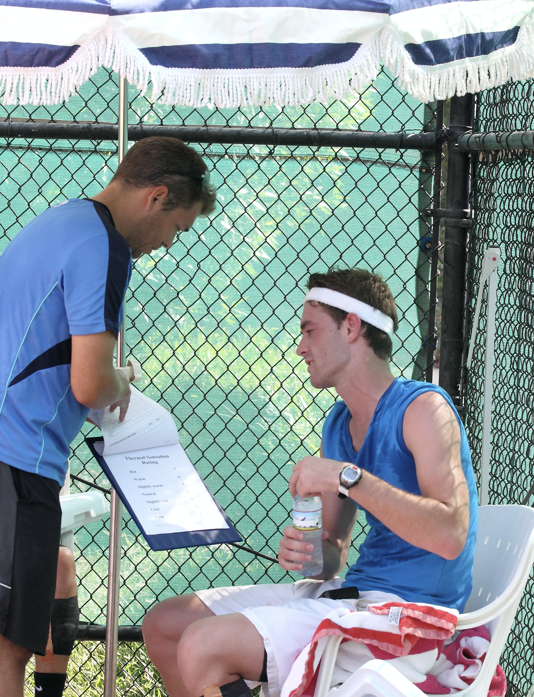

Are you a trained male or female badminton player (15-50 years old) who is curious about thermal strain experienced by badminton players with distinct training background (age, gender, performance level)?

You are invited to participate in a **research study** being conducted by researchers at the University of Western Australia.

This project **aims** to quantify the development of thermal, physiological and perceptual strain during badminton match-play in different players’ categories.

**What does participation involve?**

The completion of **one single experimental session** (~3 h in duration) including two consecutive simulated badminton games that will be *scheduled at times that are convenient for you.*

Following the study:

You will be able to receive a **summary report** detailing the general findings of the study as well as **your own personal results** including core temperature, hydration and sweat rate responses to badminton match play!

Why not volunteer to help us assess the **acute thermal and psychophysiological responses associated with playing badminton**?

***Funding:***

***Badminton World Federation***

***(Sport Science Research Grants 2022/23)***